

Malignant Comments Classifier

Submitted by:

YOUR NAME

**Amit Gawande**

**ACKNOWLEDGMENT**

I have referred below resources that helped and guided me in completion of this project as below:-

[www.w3resource.com](http://www.w3resource.com)

[www.towardsdatascience.com](http://www.towardsdatascience.com)

[www.stackoverflow.com](http://www.stackoverflow.com)

**INTRODUCTION**

* Business Problem Framing

The proliferation of social media enables people to express their opinions widely online. However, at the same time, this has resulted in the emergence of conflict and hate, making online environments uninviting for users. Although researchers have found that hate is a problem across multiple platforms, there is a lack of models for online hate detection.

* Conceptual Background of the Domain Problem

There has been a remarkable increase in the cases of cyberbullying and trolls on various social media platforms. Many celebrities and influences are facing backlashes from people and have to come across hateful and offensive comments. This can take a toll on anyone and affect them mentally leading to depression, mental illness, self-hatred and suicidal thoughts.

Internet comments are bastions of hatred and vitriol. While online anonymity has provided a new outlet for aggression and hate speech, machine learning can be used to fight it. The problem we sought to solve was the tagging of internet comments that are aggressive towards other users.

* Review of Literature

The relevant content used in the project are

* NumPy
* Pandas
* Sklearn
* Matplotlib
* Nltk
* Seaborn
* Wordcloud
* Tfidvectorizer
* Logistic Regression
* MultinomialNB
* Pasive Aggressive Classifier
* Motivation for the Problem Undertaken

Our goal is to build a prototype of online hate and abuse comment classifier which can used to classify hate and offensive comments so that it can be controlled and restricted from spreading hatred and cyberbullying.

**Analytical Problem Framing**

* Mathematical/ Analytical Modeling of the Problem

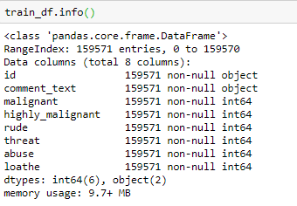

* Data Sources and their formats

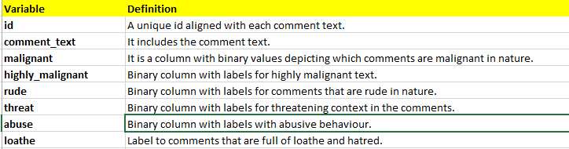

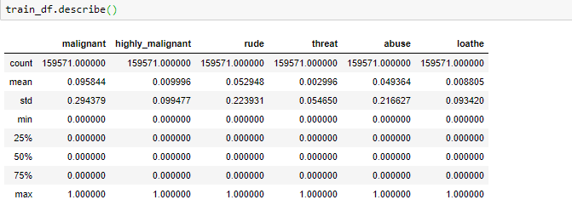

* Data Preprocessing Done

The data was cleaned by removing punctuations ,stop words.Stemming and lemmatiztaion are used to reduce word to its root form.

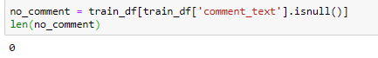

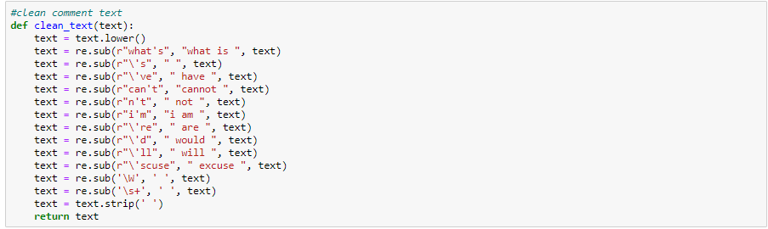

* Data Inputs- Logic- Output Relationships
* 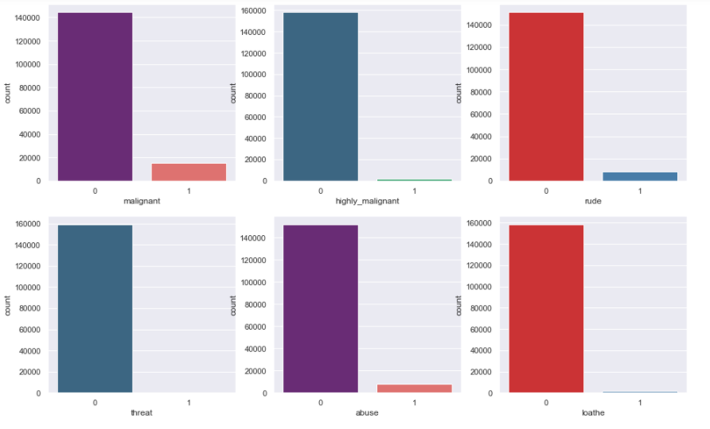

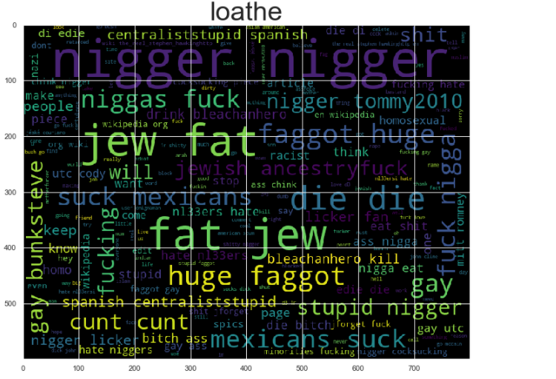

* Hardware and Software Requirements and Tools Used
* **Hardware**-64bit, 4GB RAM.
* **Software-**Excel, Anaconda,jupyter notebook

**Model/s Development and Evaluation**

* Identification of possible problem-solving approaches (methods)

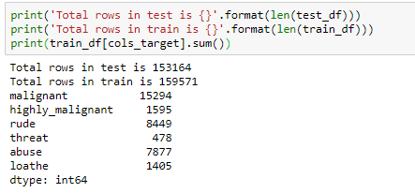

* Testing of Identified Approaches (Algorithms)

This dataset is multilabel classification problem. The approach a multi-label classification problem is to transform the problem into separate single-class classifier problems.

Binary Relevance. This is probably the simplest which treats each label as a separate single classification problems. The key assumption here though, is that there are no correlation among the various labels.

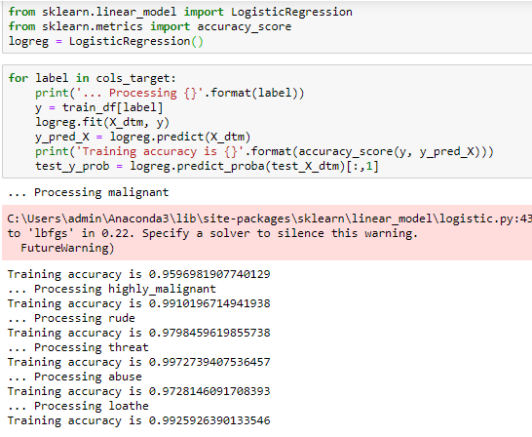

**CONCLUSION**

* Key Findings and Conclusions of the Study

Every features of dataset plays an important role in identifying the results accurately.

* Learning Outcomes of the Study in respect of Data Science
* Visualize the data using univariant / multi-variant analysis.
* Check the prediction score using accuracy score & get ROC-AUC score.
* Train data using classification models to get the best score & finalise best score giver model for this dataset.
* Save file using pickle/joblib library.